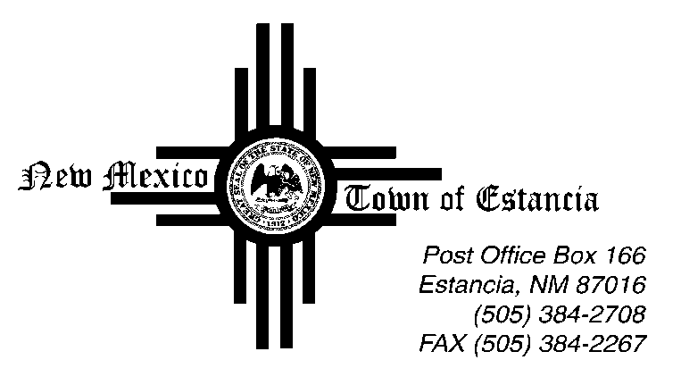

Mayor
Nathan Dial

Mayor Pro Tem
Noah Sedillo

Trustees
Morrow Hall
Stella Chavez
Albert Lovato

____________________________________________________________________________________________

Notice of Possible Quorum

06.13.2024

This Public Notice is being posted to inform the public that there will be a Possible Quorum of Town of Estancia Trustees on Friday, June 13, 2024 at The Moriarty Civic Center.

The Possible Quorum will be strictly for the purpose of attending the Code of Conduct/Open Meetings Act training at the Moriarty Civic Center. No action will be taken, and no further business will be conducted.

